Start Script:

Step 1:

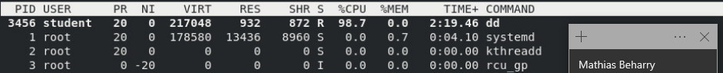

Step 2:

Step 3:

Step 4:

Step 5:

Step 6:

Evaluation Script & Finish Script:

